# Shop Bridge E-com Application

Shop Bridge E-com is a Web Application which has Web API implemented for listing:

1. Listing all the Products in the bucket.
2. Listing a single product (for provided product id).
3. Inserting new product.
4. Deleting a product.

## For Database:

A database was created in MySQL with ProductID, Name, Description, Price, Category.

The Product Model class in the Web Application is the Class based on this DB table.

Refer the screenshot below.

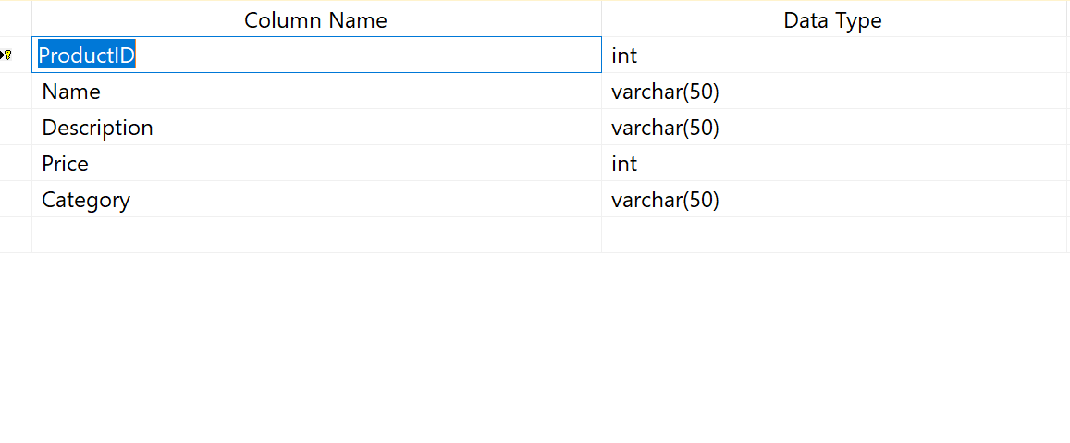

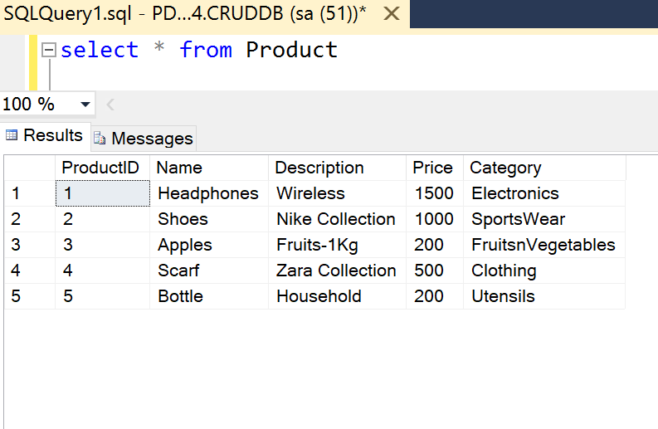

## For Testing:

You can run the application in browser and use <https://localhost:44384/api/Products> to view all the Products. (Post Web API).Refer Screenshot below.

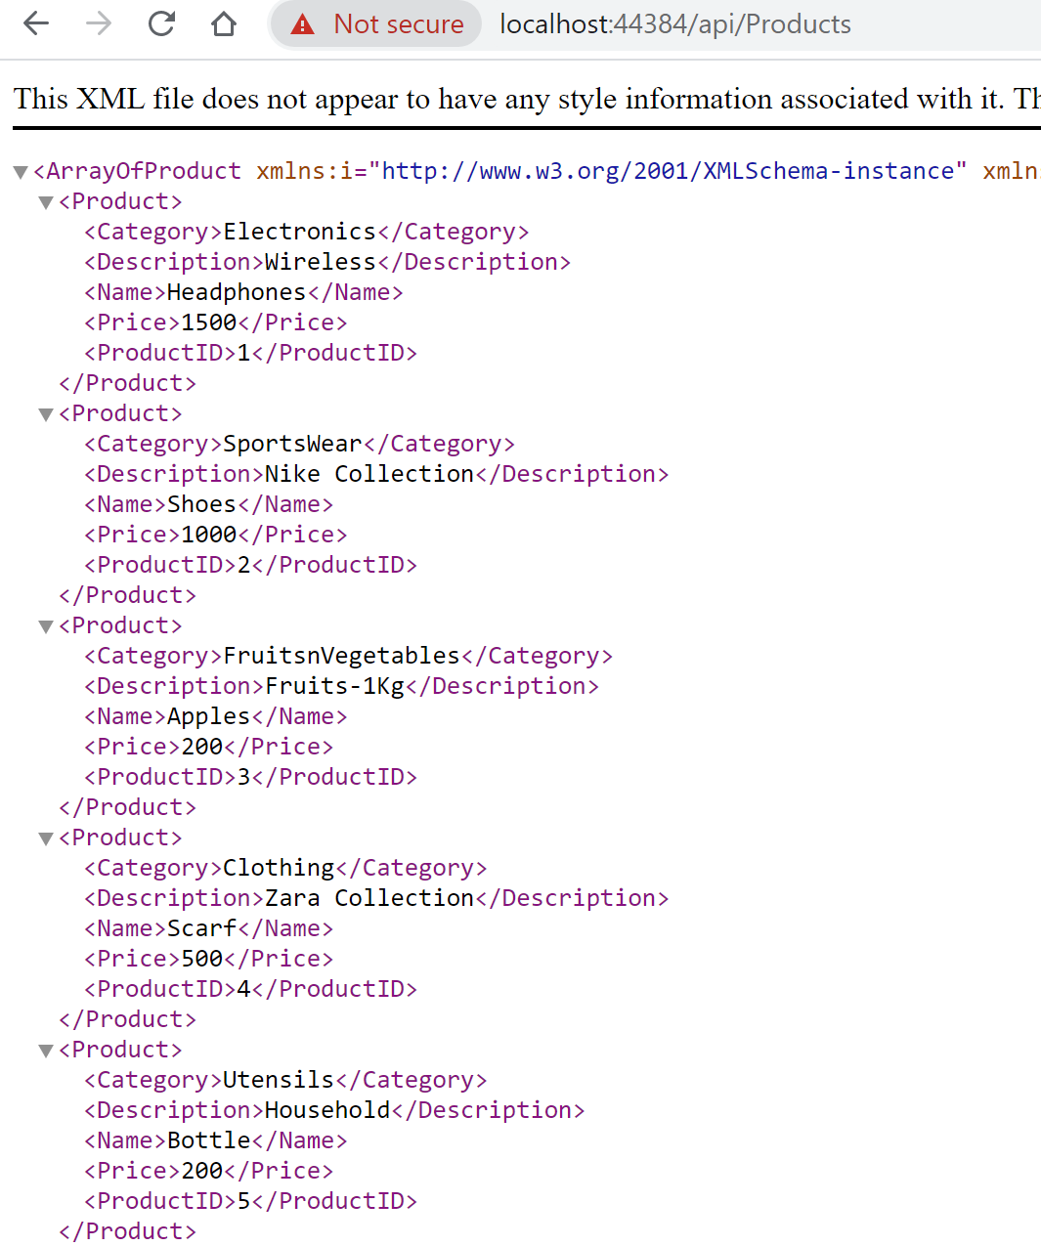

Similarly for other operations I have tested the implementation using Postman –

Adding the Postman Collection with the Code.